Practical 9
1. Aim
To configure the Remote Desktop Client on Windows 11 Home and access a remote desktop running on a target Windows system.
2. Requirements
- Client PC: Windows 10/11 Home or Pro
- Target PC: Windows Server 2025 (running on VMWare Workstation Pro)
- Network connection mode: Bridged (in VMWare’s VM settings)
- Target PC’s IP address or hostname
3. Theory
Remote Desktop is a Windows feature that allows users to access and control a remote computer through a network. The host PC uses the Remote Desktop Client to connect to the target system and display its desktop.
In this practical, Windows 11 Home is used as the client computer, while the target Windows system provides the remote desktop. The built-in Remote Desktop Connection utility (mstsc) is used to establish the connection.
4. Procedure
Step 1: Configure the target computer
- Start the target PC on VMWare Workstation Pro.
- Open Settings → System → About and check the Windows edition.
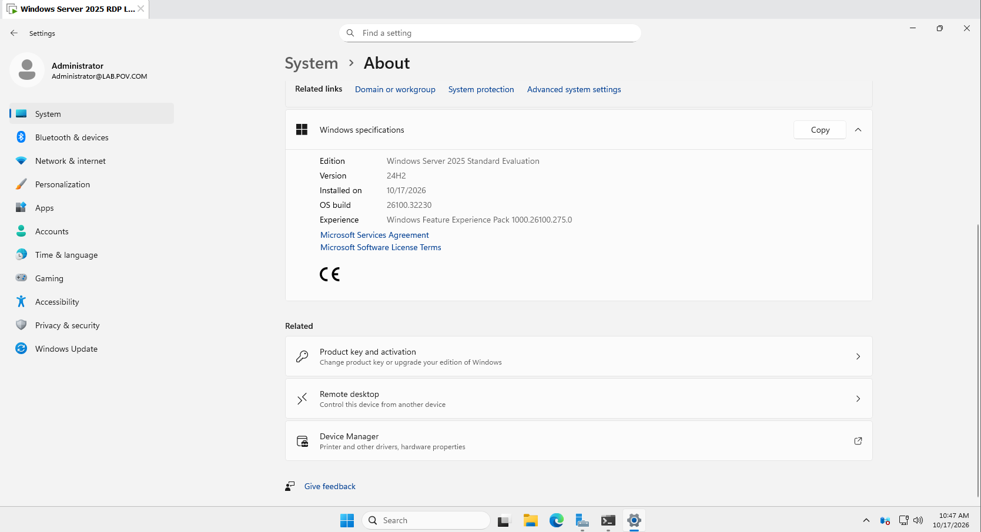
- Open Settings → System → Remote Desktop.
- Turn on Remote Desktop if the option is available.
- Confirm the setting when prompted.
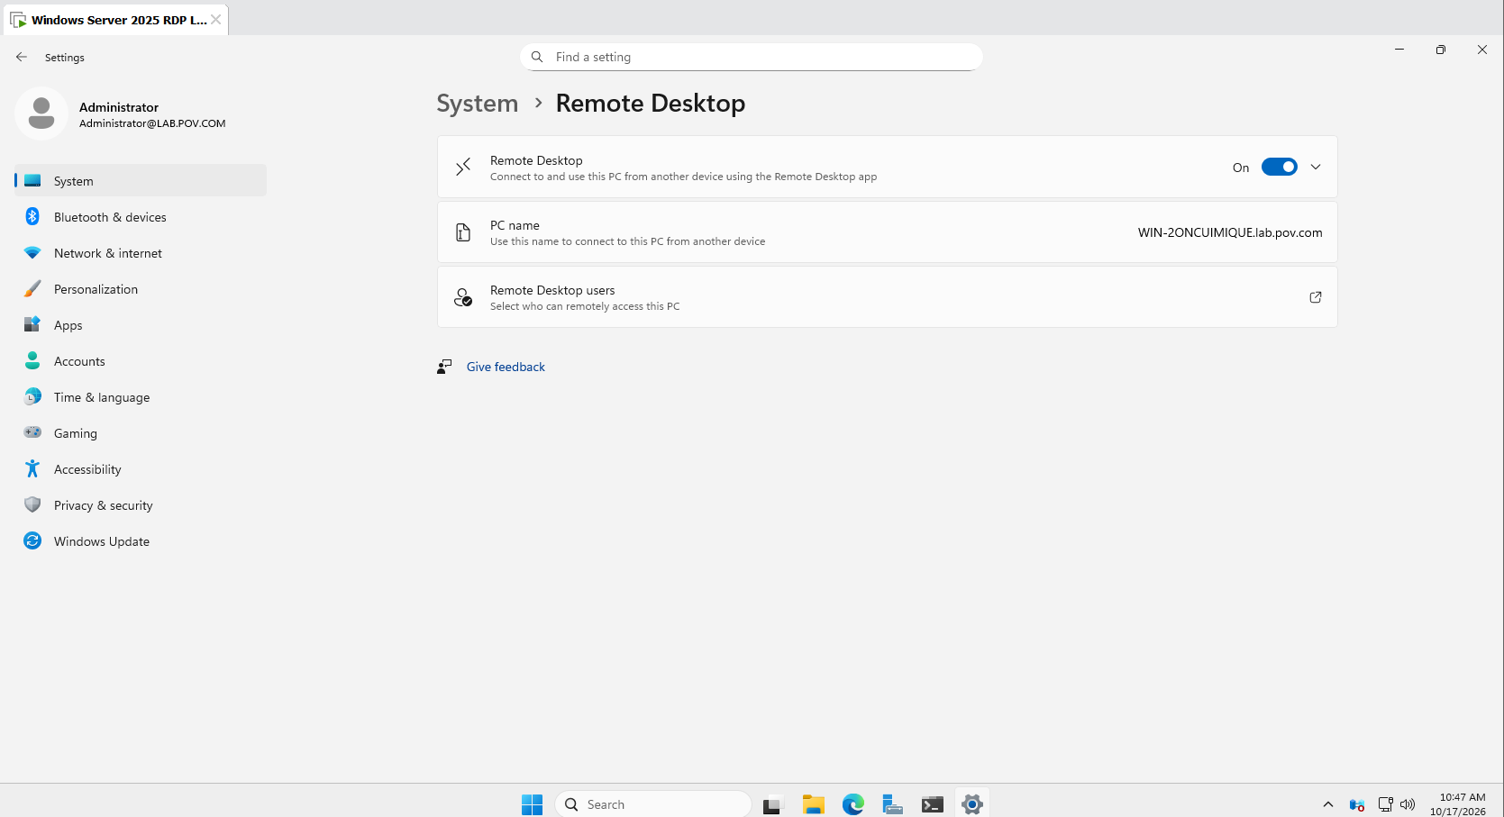
- Note the target computer's name.
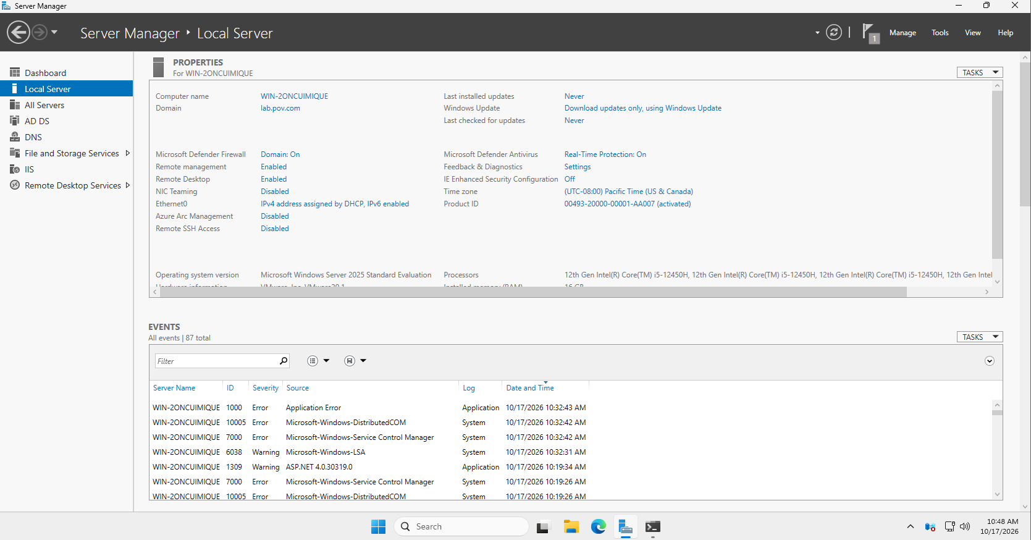
- Ensure the account used for the connection has a password and permission to connect remotely.
Step 2: Find the target IP address
- On the target computer, press Windows + R.
- Type cmd and press Enter.
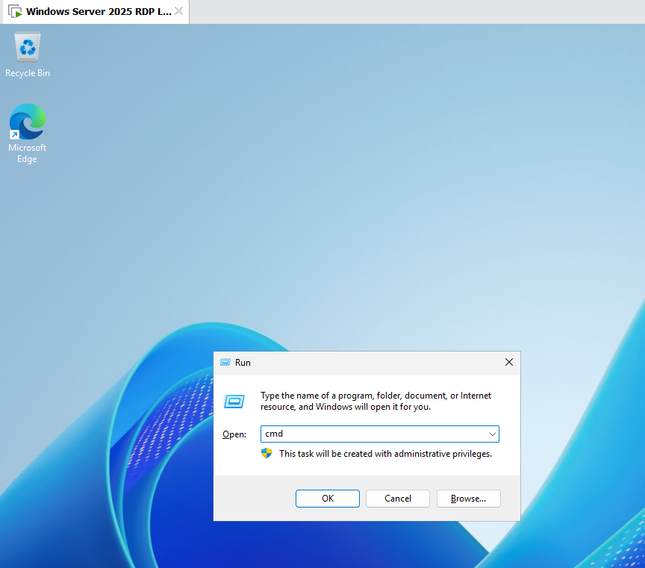
- Execute the following command:
ipconfig
- Find the active network adapter and note its IPv4 Address.
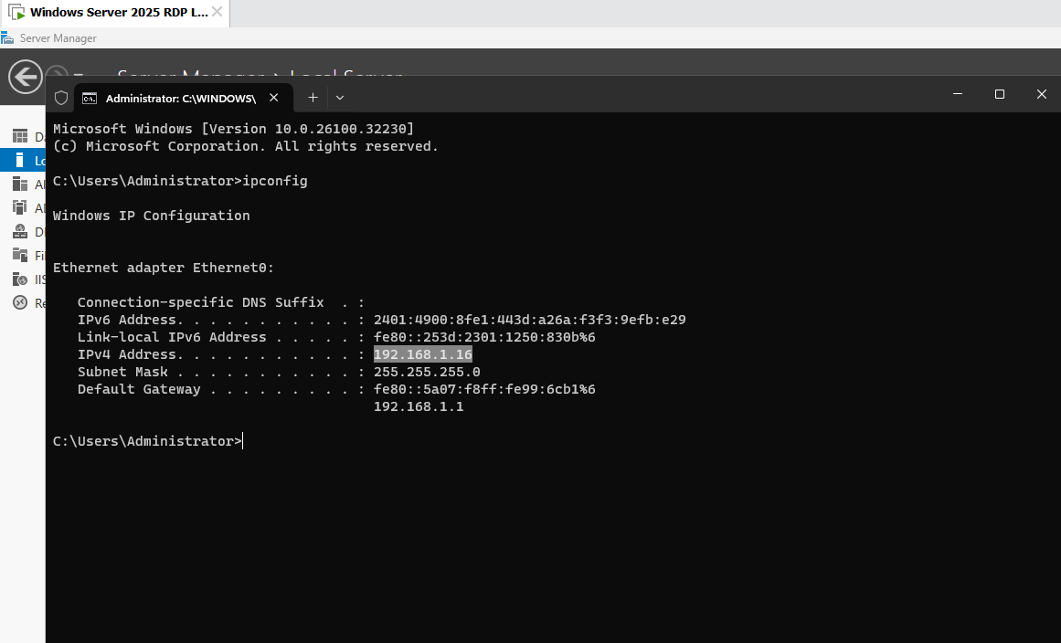
Step 3: Open the Remote Desktop Client
- On the Windows 11 Home client PC, press Windows + R.
- Type mstsc and press Enter.
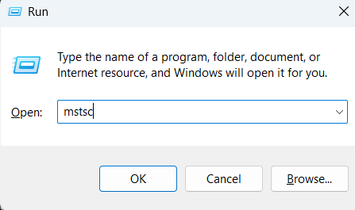
- The Remote Desktop Connection window will appear.
Step 4: Configure the connection
- Enter the target computer's IPv4 address in the Computer field.
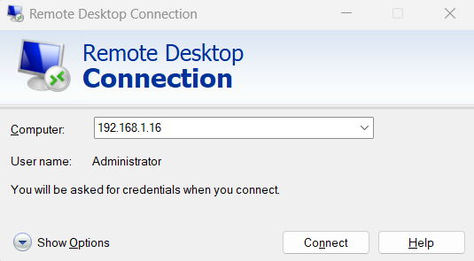
- Click Show Options.
- Enter the target account's username if required.
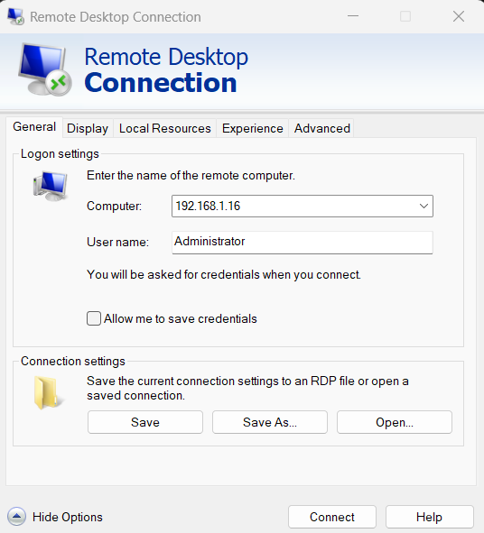
- Adjust display or local resource settings if needed.
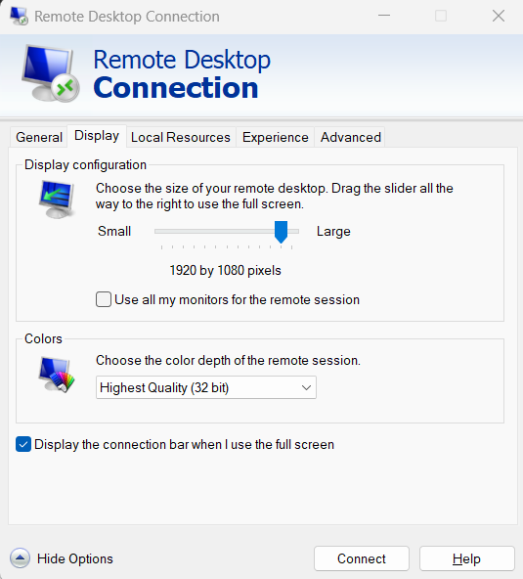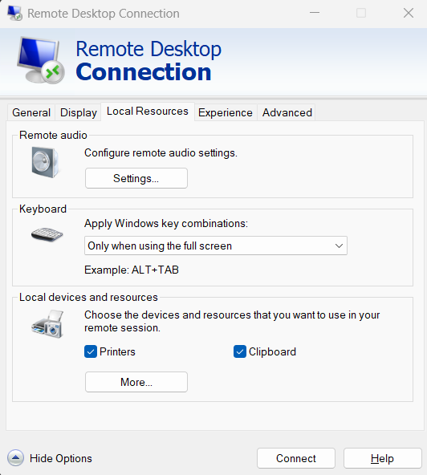
Step 5: Connect to the target
- Click Connect.
- Enter the target computer's password when prompted.
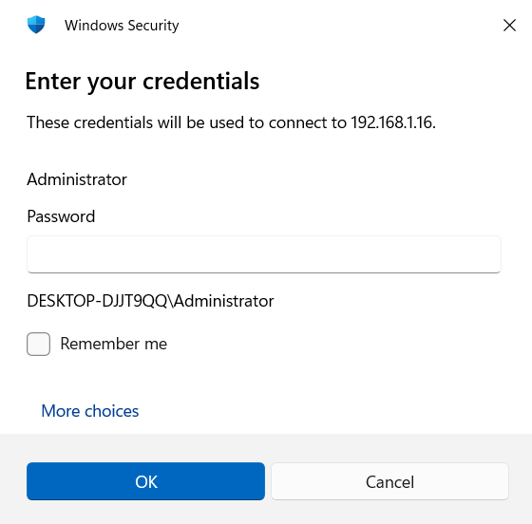
- Verify the target computer's identity before accepting any certificate warning.
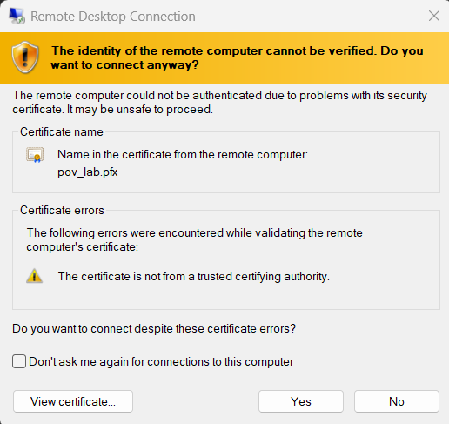
- After successful authentication, the target desktop should appear on the host PC.
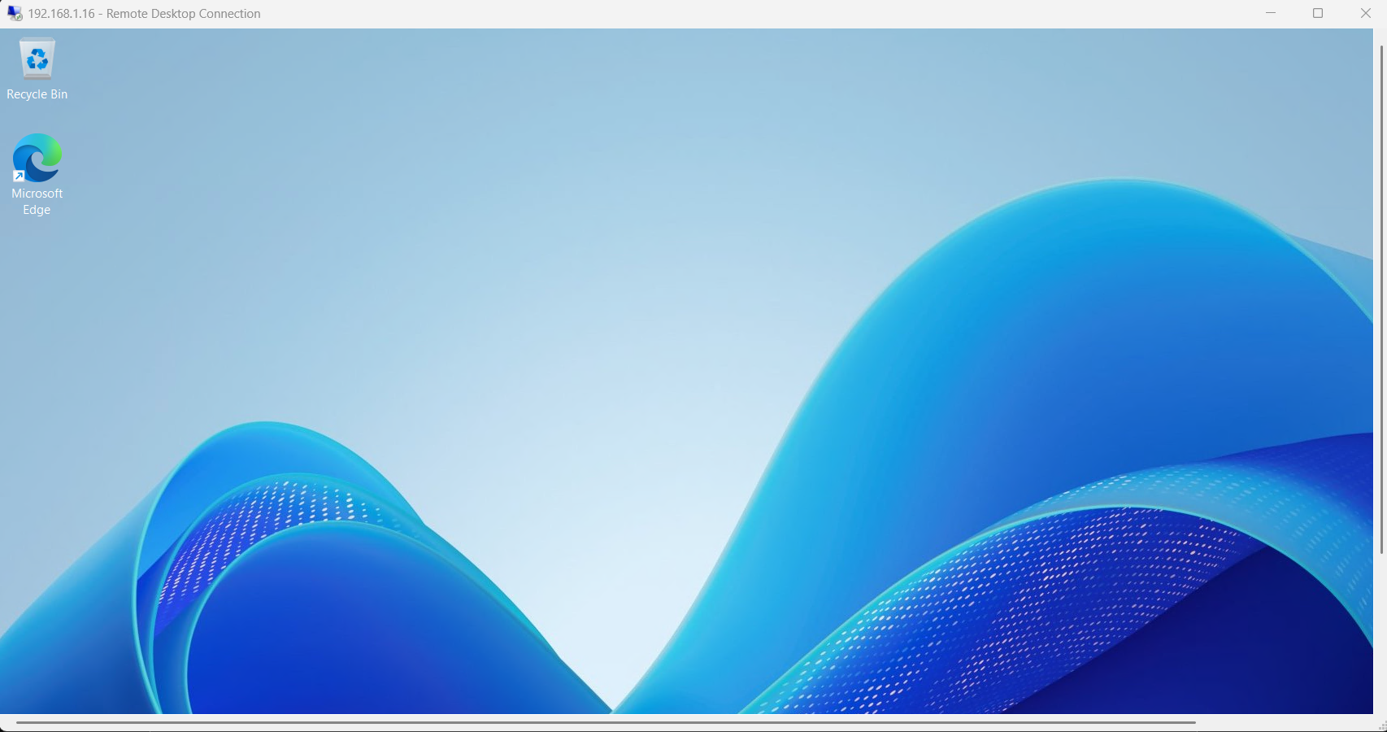
Step 6: End the session
- Save any work performed on the target computer.
- Sign out of the remote Windows session or disconnect as required.
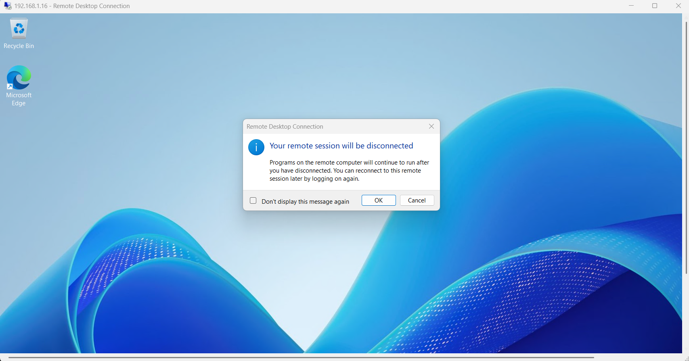
5. Result
The Remote Desktop Client on Windows 11 Home was configured to connect to the target Windows computer. Remote desktop access was successful when the target system supported incoming Remote Desktop connections and the network and credentials were configured correctly.
6. Precautions
- Verify the target IP address before connecting.
- Use a strong password and valid credentials.
- Ensure both computers can communicate over the network.
- Enable Remote Desktop only on supported Windows editions.
- Allow Remote Desktop through the firewall only on trusted networks.
- Do not expose Remote Desktop directly to the internet without appropriate security protections.

